**RECRUITMENT SYSTEM**

Use case diagram:

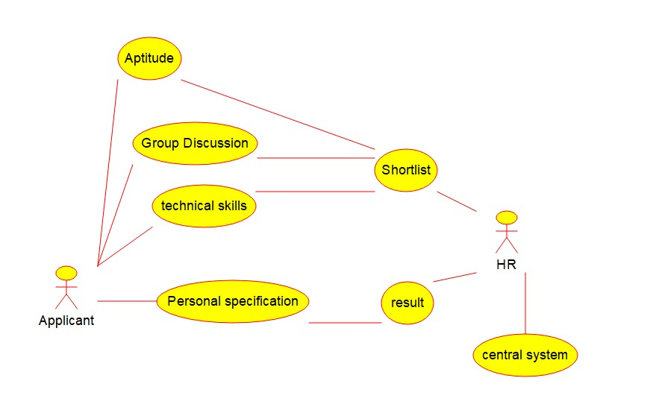

Object diagram:

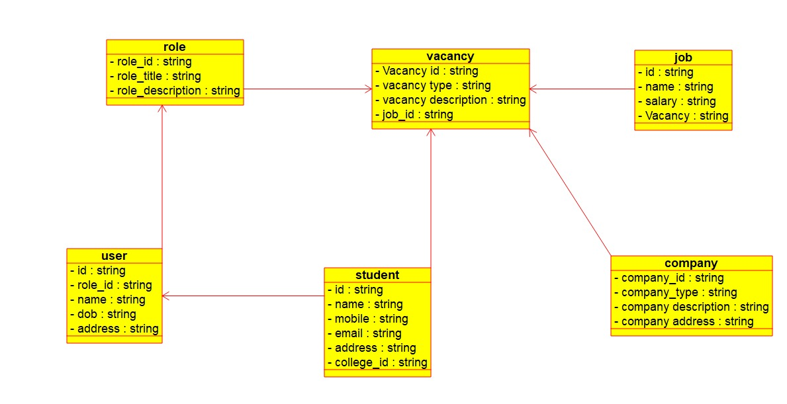

Class diagram:

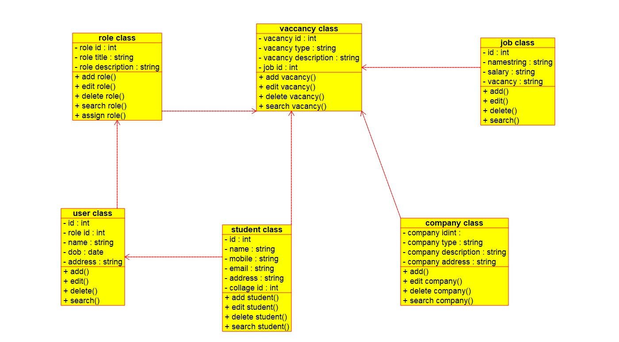

Component diagram:

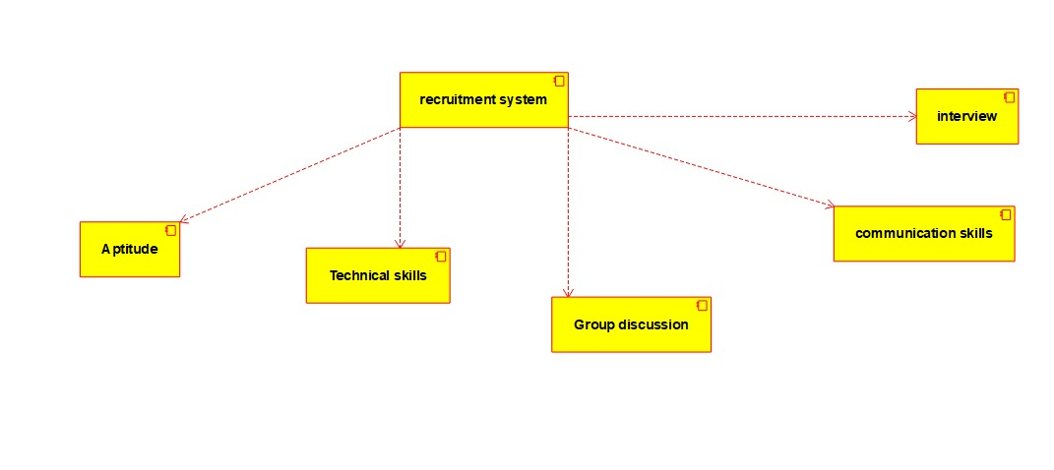

Sequence diagram:

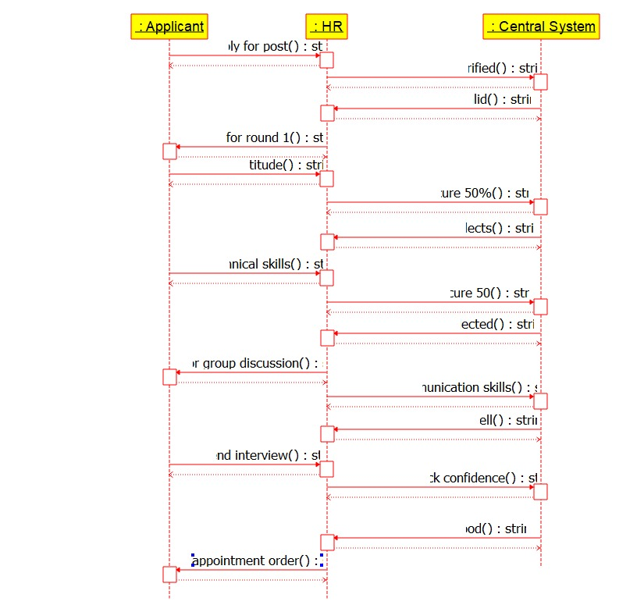

Collaboration diagram:

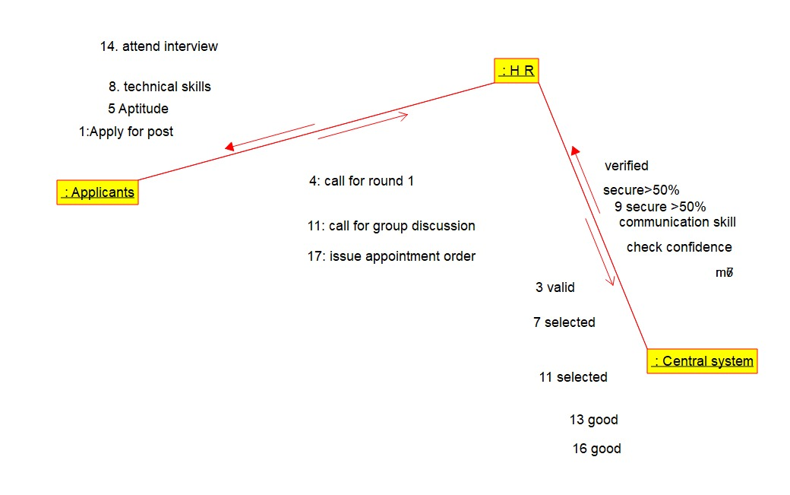

Deployment diagram:

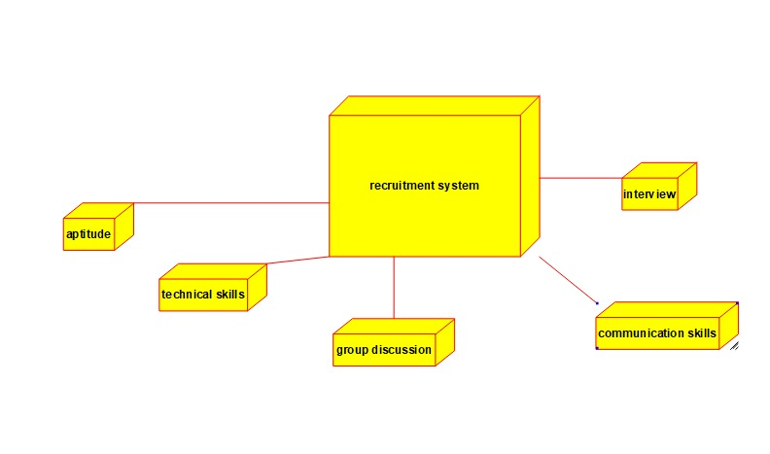

Activity diagram:



State chart diagram:

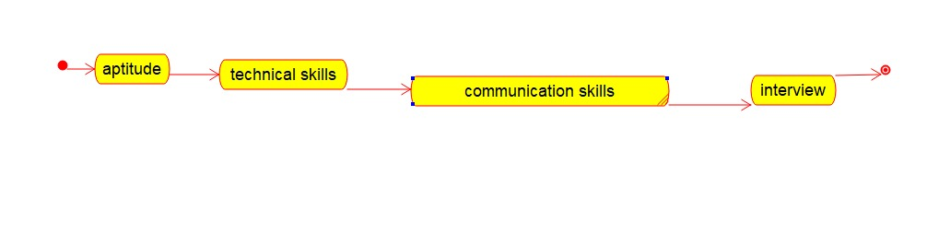

Program:

User case:

/**

* Class admin

*/

public class admin {

//

// Fields

//

private integer id;

private char name;

//

// Constructors

//

public admin () { };

//

// Methods

//

//

// Accessor methods

//

/**

* Set the value of id

* @param newVar the new value of id

*/

private void setId (integer newVar) {

id = newVar;

}

/**

* Get the value of id

* @return the value of id

*/

private integer getId () {

return id;

}

/**

* Set the value of name

* @param newVar the new value of name

*/

private void setName (char newVar) {

name = newVar;

}

/**

* Get the value of name

* @return the value of name

*/

private char getName () {

return name;

}

//

// Other methods

//

/**

*/

public void view_product()

{

}

/**

*/

public void add_product()

{

}

/**

*/

public void delete_product()

{

}

/**

*/

public void modify_product()

{

}

/**

*/

public void make_shipment()

{

}

/**

*/

public void confirm_delivery()

{

}

}

/**

* Class user_class

*/

public class user_class {

//

// Fields

//

private int id;

private int role_id;

private String name;

private date dob;

private String address;

//

// Constructors

//

public user_class () { };

//

// Methods

//

//

// Accessor methods

//

/**

* Set the value of id

* @param newVar the new value of id

*/

private void setId (int newVar) {

id = newVar;

}

/**

* Get the value of id

* @return the value of id

*/

private int getId () {

return id;

}

/**

* Set the value of role_id

* @param newVar the new value of role_id

*/

private void setRole_id (int newVar) {

role_id = newVar;

}

/**

* Get the value of role_id

* @return the value of role_id

*/

private int getRole_id () {

return role_id;

}

/**

* Set the value of name

* @param newVar the new value of name

*/

private void setName (String newVar) {

name = newVar;

}

/**

* Get the value of name

* @return the value of name

*/

private String getName () {

return name;

}

/**

* Set the value of dob

* @param newVar the new value of dob

*/

private void setDob (date newVar) {

dob = newVar;

}

/**

* Get the value of dob

* @return the value of dob

*/

private date getDob () {

return dob;

}

/**

* Set the value of address

* @param newVar the new value of address

*/

private void setAddress (String newVar) {

address = newVar;

}

/**

* Get the value of address

* @return the value of address

*/

private String getAddress () {

return address;

}

//

// Other methods

//

/**

*/

public void add()

{

}

/**

*/

public void edit()

{

}

/**

*/

public void delete()

{

}

/**

*/

public void search()

{

}

}

Student:

/**

* Class admin

*/

public class admin {

//

// Fields

//

private integer id;

private char name;

//

// Constructors

//

public admin () { };

//

// Methods

//

//

// Accessor methods

//

/**

* Set the value of id

* @param newVar the new value of id

*/

private void setId (integer newVar) {

id = newVar;

}

/**

* Get the value of id

* @return the value of id

*/

private integer getId () {

return id;

}

/**

* Set the value of name

* @param newVar the new value of name

*/

private void setName (char newVar) {

name = newVar;

}

/**

* Get the value of name

* @return the value of name

*/

private char getName () {

return name;

}

//

// Other methods

//

/**

*/

public void view_product()

{

}

/**

*/

public void add_product()

{

}

/**

*/

public void delete_product()

{

}

/**

*/

public void modify_product()

{

}

/**

*/

public void make_shipment()

{

}

/**

*/

public void confirm_delivery()

{

}

}

/**

* Class student_class

*/

public class student_class {

//

// Fields

//

private int id;

private String name;

private String mobile;

private String email;

private String address;

private int collage_id;

//

// Constructors

//

public student_class () { };

//

// Methods

//

//

// Accessor methods

//

/**

* Set the value of id

* @param newVar the new value of id

*/

private void setId (int newVar) {

id = newVar;

}

/**

* Get the value of id

* @return the value of id

*/

private int getId () {

return id;

}

/**

* Set the value of name

* @param newVar the new value of name

*/

private void setName (String newVar) {

name = newVar;

}

/**

* Get the value of name

* @return the value of name

*/

private String getName () {

return name;

}

/**

* Set the value of mobile

* @param newVar the new value of mobile

*/

private void setMobile (String newVar) {

mobile = newVar;

}

/**

* Get the value of mobile

* @return the value of mobile

*/

private String getMobile () {

return mobile;

}

/**

* Set the value of email

* @param newVar the new value of email

*/

private void setEmail (String newVar) {

email = newVar;

}

/**

* Get the value of email

* @return the value of email

*/

private String getEmail () {

return email;

}

/**

* Set the value of address

* @param newVar the new value of address

*/

private void setAddress (String newVar) {

address = newVar;

}

/**

* Get the value of address

* @return the value of address

*/

private String getAddress () {

return address;

}

/**

* Set the value of collage_id

* @param newVar the new value of collage_id

*/

private void setCollage_id (int newVar) {

collage_id = newVar;

}

/**

* Get the value of collage_id

* @return the value of collage_id

*/

private int getCollage_id () {

return collage_id;

}

//

// Other methods

//

/**

*/

public void add_student()

{

}

/**

*/

public void edit_student()

{

}

/**

*/

public void delete_student()

{

}

/**

*/

public void search_student()

{

}

}